Elizabeth Hutton

ID 3144718310

BME 413

10/26/18

Programming Assignment 1

**Question 1:**

1. MATLAB Code to plot sine, cosine, and square waves:

f = 4; %4 Hz frequency

fs = 1000; %sampling frequency

N = 1000; %num sampling points

t = (0:N-1)/fs; %time vector

sine = sin(2*pi*f*t);

sq = square(2*pi*f*t);

cosine = cos(2*pi*f*t);

figure;

plot(sine, 'b'); hold on;

plot(cosine, 'r'); hold on;

plot(sq,'k')

xlabel('Time (seconds)')

ylabel('Signal')

ylim([-1.25 1.25])

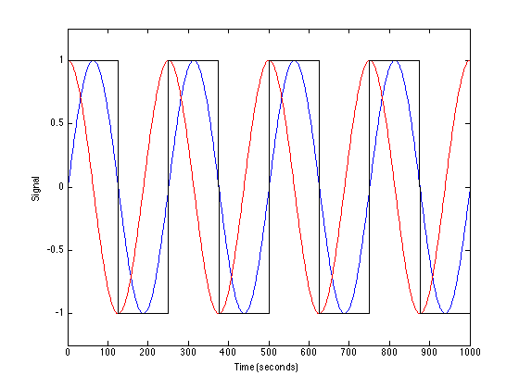

1. Calculating signal correlations in MATLAB:

r_sin = mean(sine.*sq);

% = 0.6366

r_cos = mean(cosine.*sq);

% = 0.0080

By Hand:

**Question 2:**

1. Sampling frequency fs = number of samples / time interval

load dataforEEG.mat

N = length(eeg); %num samples

interval = 16; %16 sec signal

fs = N/interval; %sampling frequency

t = (1:length(eeg))/fs;

1. Cross-Correlation:

rmax = (1:20);

for i=1:20

x = sin(2*pi*i*t);

r = xcorr(eeg,x);

rmax(i) = max(r);

end

figure;

plot(rmax)

xlabel('Frequency (Hz)')

ylabel('Max Xcorr')

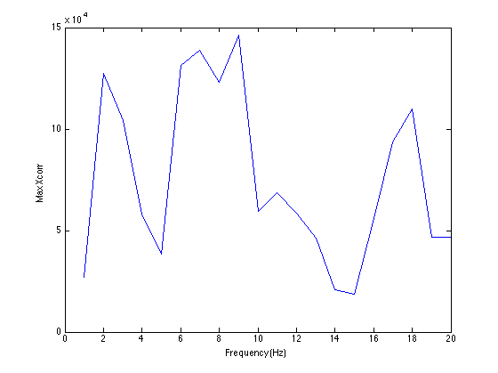

1. Looking at the above plot of the maximum value of the cross-correlation at each frequency, there is a peak, the highest peak, within the 7-12 Hz range. This is the alpha wave and indicates that there is maximal correlation with the sinusoidal reference signal within this range of frequencies.

**Question 3:**

1. Plotting Magnitude and Phase Spectrum of Fourier Transform

N = length(resp); %num samples

fs = N / 125; %sampling frequency for 125s interval

f = (1:N)*fs/N; %frequency vector

X = fft(resp); %complex fourier transform

%only plot spectrum up to 2Hz

index = round(2*(N/fs));

%plot magnitude

subplot(2,1,1);

plot(f(1:index-1),abs(X(2:index)),'k');

xlabel('Frequency (Hz)');

ylabel('Magnitude');

%unwrap smooths out discontinuities

phase = unwrap(angle(X));

%plot phase

subplot(2,1,2);

plot(f(1:index-1),phase(2:index),'k');

xlabel('Frequency (Hz)');

ylabel('Phase');

(plot on next page)

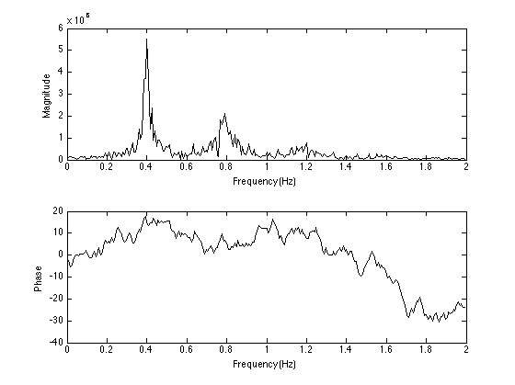

1. To find the breaths per minute, first find the breathing frequency based on the argmax of the frequency magnitude spectrum. The time it takes to make one breath is 1 divided by this frequency, which is 2.5 seconds. To obtain the number of breaths per min, calculate how many 2.5 second breaths can be made within a 60s interval: 60/2.5 = 24 breaths per minute.

[peak, n_peak] = max(abs(X(2:index)));

max_freq = f(n_peak); %breathing frequency

max_time = 1/max_freq;

breaths_per_minute = 60 / max_time;

% = 24 breaths per minute